Simon’s Problem-

Given a 2 to 1 function f(x) such that f(x)=f(x xor s), find s.

Solution-

Basic solution-

1. Set up a random superposition 1/sqrt(2)|r> + 1/sqrt(2)|r^s>

2. Fourier sample (hadamard gate) to get a random y : y.s = 0 (mod 2)

3. Repeat steps n-1 times to generate n-1 linear equations in s.

Solve for s. (Gaussian elimination)

Circuit Diagram :-

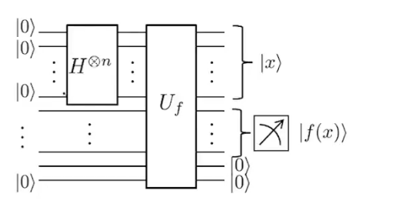
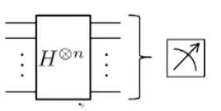

State after first Hadamard transform :-

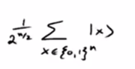

After that, we run a query that copies f(x) on the 2nd register. Then we measure the second register. State after measurement :-

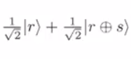

Now, we Fourier sample the above state (1st n qubits). We get the following thing-
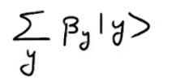

Now, beta y is of the form-

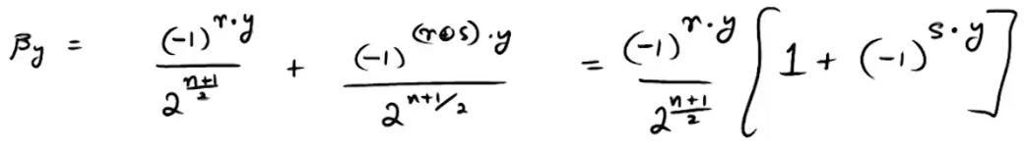
Now, after sampling, we measure the first first register of n qubits. With equal probability, it will collaps to the state y. Hence, we’ll have the following cases -

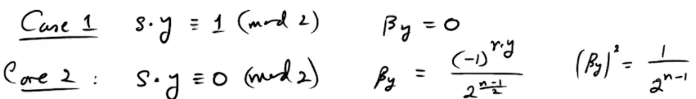
In the end, we get one linear equation (modulo 2).

